Acoustic emission (AE) is the sound waves produced when a material undergoes stress (internal change), as a result of an external force. AE is a phenomenon occurring in for instance mechanical loading generating sources of elastic waves. This occurrence is the result of a small surface displacement of a material produced due to stress waves generated when the energy in a material, or on its surface is released rapidly. The wave generated by the source is of practical interest in methods used to stimulate and capture AE in a controlled fashion, for study and/or use in inspection, quality control, system feedback, process monitoring and others.

Acoustic Emission (AE) refers to the generation of transient elastic waves produced by a sudden redistribution of stress in a material. When a structure is subjected to an external stimulus (change in pressure, load, or temperature), localized sources trigger the release of energy, in the form of stress waves, which propagate to the surface and are recorded by sensors. With the right equipment and setup, motions on the order of picometers (10 -12 m) can be identified. Sources of AE vary from natural events like earthquakes and rockbursts to the initiation and growth of cracks, slip and dislocation movements

Detection and analysis of AE signals can supply valuable information regarding the origin and importance of a discontinuity in a material. Because of the versatility of Acoustic Emission Testing (AET), it has many industrial applications (e.g. assessing structural integrity, detecting flaws, testing for leaks, or monitoring weld quality) and is used extensively as a research tool.
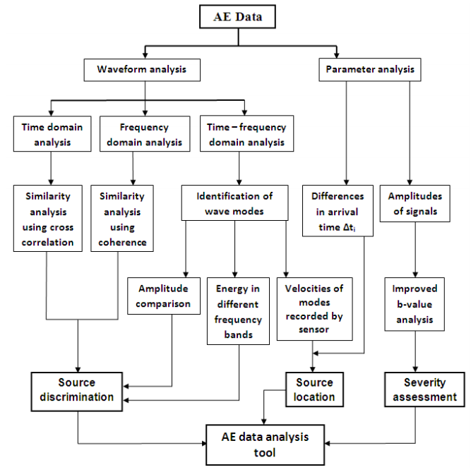

Noise
The sensitivity of an acoustic emission system is often limited by the amount of background noise nearby. Noise in AE testing refers to any undesirable signals detected by the sensors. Examples of these signals include frictional sources (e.g. loose bolts or movable connectors that shift when exposed to wind loads) and impact sources (e.g. rain, flying objects or wind-driven dust) in bridges. Sources of noise may also be present in applications where the area being tested may be disturbed by mechanical vibrations (e.g. pumps).
To compensate for the effects of background noise, various procedures can be implemented. Some possible approaches involve fabricating special sensors with electronic gates for noise blocking, taking precautions to place sensors as far away as possible from noise sources, and electronic filtering (either using signal arrival times or differences in the spectral content of true AE signals and background noise).

Attenuation
The intensity of an AE signal detected by a sensor is considerably lower than the intensity that would have been observed in the close proximity of the source. This is due to attenuation. There are three main causes of attenuation, beginning with geometric spreading. As an AE spreads from its source in a plate-like material, its amplitude decays by 30% every time it doubles its distance from the source. In three-dimensional structures, the signal decays on the order of 50%. This can be traced back to the simple conservation of energy. Another cause of attenuation is material damping, as alluded to in the previous paragraph. While an AE wave passes through a material, its elastic and kinetic energies are absorbed and converted into heat. The third cause of attenuation is wave scattering. Geometric discontinuities (e.g. twin boundaries, nonmetallic inclusions, or grain boundaries) and structural boundaries both reflect some of the wave energy that was initially transmitted.

Measurements of the effects of attenuation on an AE signal can be performed with a simple apparatus known as a Hsu-Nielson Source. This consists of a mechanical pencil with either 0.3 or 0.5 mm 2H lead that is passed through a cone-shaped Teflon shoe designed to place the lead in contact with the surface of a material at a 30 degree angle. When the pencil lead is pressed and broken against the material, it creates a small, local deformation that is relieved in the form of a stress wave, similar to the type of AE signal produced by a crack. By using this method, simulated AE sources can be created at various sites on a structure to determine the optimal position for the placement of sensors and to ensure that all areas of interest are within the detection range of the sensor or sensors.
Acoustic Emission Phenomenon
AE is commonly defined as transient elastic waves within a material, caused by the release of localized stress energy. Hence, an event source is the phenomenon which releases elastic energy into the material, which then propagates as an elastic wave. Acoustic emissions can be detected in frequency ranges under 1 kHz, and have been reported at frequencies up to 100 MHz, but most of the released energy is within the 1 kHz to 1 MHz range. Rapid stress-releasing events generate a spectrum of stress waves starting at 0 Hz, and typically falling off at several MHz.
The three major applications of AE techniques are:
1) source location - determine the locations where an event source occurred
2) material mechanical performance - evaluate and characterize materials/structures; and
3) health monitoring - monitor the safety operation of a structure, i.e. bridges, pressure containers, and pipe lines, etc.
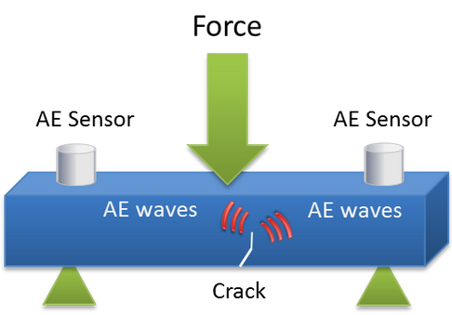

With the equipment configured and setup complete, AE testing may begin. The sensor is coupled to the test surface and held in place with tape or adhesive. An operator then monitors the signals which are excited by the induced stresses in the object. When a useful transient, or burst signal is correctly obtained, parameters like amplitude, counts, measured area under the rectified signal envelope (MARSE), duration, and rise time can be gathered. Each of the AE signal feature shown in the image is described below.
Amplitude, A, is the greatest measured voltage in a waveform and is measured in decibels (dB). This is an important parameter in acoustic emission inspection because it determines the detectability of the signal. Signals with amplitudes below the operator-defined, minimum threshold will not be recorded.
Rise time, R, is the time interval between the first threshold crossing and the signal peak. This parameter is related to the propagation of the wave between the source of the acoustic emission event and the sensor. Therefore, rise time is used for qualification of signals and as a criterion for noise filter.
Duration, D, is the time difference between the first and last threshold crossings. Duration can be used to identify different types of sources and to filter out noise. Like counts (N), this parameter relies upon the magnitude of the signal and the acoustics of the material.
MARSE, E, sometimes referred to as energy counts, is the measure of the area under the envelope of the rectified linear voltage time signal from the transducer. This can be thought of as the relative signal amplitude and is useful because the energy of the emission can be determined. MARSE is also sensitive to the duration and amplitude of the signal, but does not use counts or user defined thresholds and operating frequencies. MARSE is regularly used in the measurements of acoustic emissions.
Counts, N, refers to the number of pulses emitted by the measurement circuitry if the signal amplitude is greater than the threshold. Depending on the magnitude of the AE event and the characteristics of the material, one hit may produce one or many counts. While this is a relatively simple parameter to collect, it usually needs to be combined with amplitude and/or duration measurements to provide quality information about the shape of a signal.

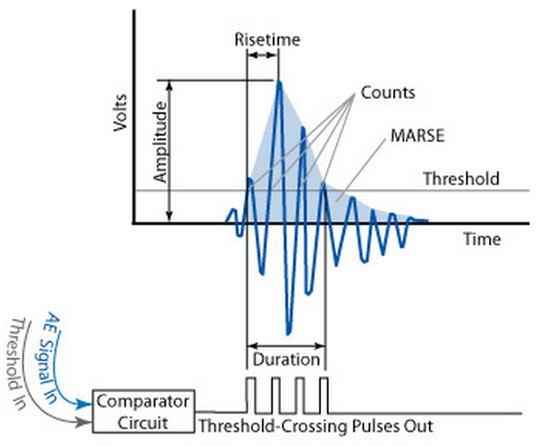

-
-

Equipment
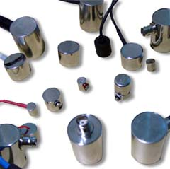 | 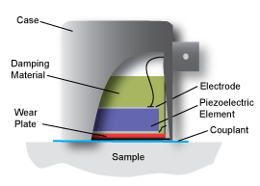
Acoustic emission testing can be performed in the field with portable instruments or in a stationary laboratory setting. Typically, systems contain a sensor, preamplifier, filter, and amplifier, along with measurement, display, and storage equipment (e.g. oscilloscopes, voltmeters, and personal computers). Acoustic emission sensors respond to dynamic motion that is caused by an AE event. This is achieved through transducers which convert mechanical movement into an electrical voltage signal. The transducer element in an AE sensor is almost always a piezoelectric crystal, which is commonly made from a ceramic such as lead zirconate titanate (PZT). Transducers are selected based on operating frequency, sensitivity and environmental characteristics, and are grouped into two classes: resonant and broadband. The majority of AE equipment is responsive to movement in its typical operating frequency range of 30 kHz to 1 MHz. For materials with high attenuation (e.g. plastic composites), lower frequencies may be used to better distinguish AE signals. The opposite holds true as well.
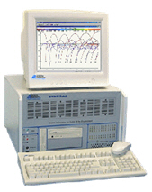
Ideally, the AE signal that reaches the mainframe will be free of background noise and electromagnetic interference. Unfortunately, this is not realistic. However, sensors and preamplifiers are designed to help eliminate unwanted signals. First, the preamplifier boosts the voltage to provide gain and cable drive capability. To minimize interference, a preamplifier is placed close to the transducer; in fact, many transducers today are equipped with integrated preamplifiers. Next, the signal is relayed to a bandpass filter for elimination of low frequencies (common to background noise) and high frequencies. Following completion of this process, the signal travels to the acoustic system mainframe and eventually to a computer or similar device for analysis and storage. Depending on noise conditions, further filtering or amplification at the mainframe may still be necessary.
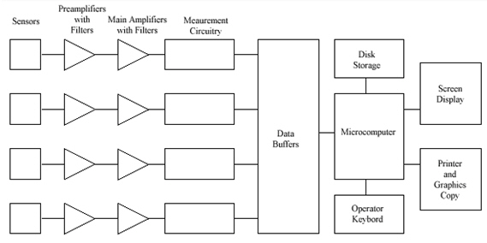
Schematic Diagram of a Basic Four-channel Acoustic Emission Testing System
After passing the AE system mainframe, the signal comes to a detection/measurement circuit as shown in the figure directly above. Note that multiple-measurement circuits can be used in multiple sensor/channel systems for source location purposes (to be described later). At the measurement circuitry, the shape of the conditioned signal is compared with a threshold voltage value that has been programmed by the operator. Signals are either continuous (analogous to Gaussian, random noise with amplitudes varying according to the magnitude of the AE events) or burst-type. Each time the threshold voltage is exceeded, the measurement circuit releases a digital pulse. The first pulse is used to signify the beginning of a hit. (A hit is used to describe the AE event that is detected by a particular sensor. One AE event can cause a system with numerous channels to record multiple hits.) Pulses will continue to be generated while the signal exceeds the threshold voltage. Once this process has stopped for a predetermined amount of time, the hit is finished (as far as the circuitry is concerned). The data from the hit is then read into a microcomputer and the measurement circuit is reset.
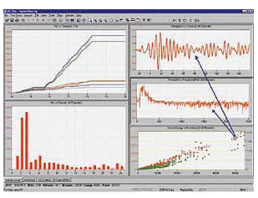
Hit Driven AE Systems and Measurement of Signal Features
Although several AE system designs are available (combining various options, sensitivity, and cost), most AE systems use a hit-driven architecture. The hit-driven design is able to efficiently measure all detected signals and record digital descriptions for each individual feature (detailed later in this section). During periods of inactivity, the system lies dormant. Once a new signal is detected, the system records the hit or hits, and the data is logged for present and/or future display.
Also common to most AE systems is the ability to perform routine tasks that are valuable for AE inspection. These tasks include quantitative signal measurements with corresponding time and/or load readings, discrimination between real and false signals (noise), and the collection of statistical information about the parameters of each signal.

Applications
Acoustic emission is a very versatile, non-invasive way to gather information about a material or structure. Acoustic Emission testing (AET) is be applied to inspect and monitor pipelines, pressure vessels, storage tanks, bridges, aircraft, and bucket trucks, and a variety of composite and ceramic components. It is also used in process control applications such as monitoring welding processes. A few examples of AET applications follow.
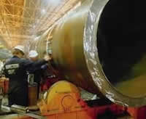
Weld Monitoring
During the welding process, temperature changes induce stresses between the weld and the base metal. These stresses are often relieved by heat treating the weld. However, in some cases tempering the weld is not possible and minor cracking occurs. Amazingly, cracking can continue for up to 10 days after the weld has been completed. Using stainless steel welds with known inclusions and accelerometers for detection purposes and background noise monitoring, it was found by W. D. Jolly (1969) that low level signals and more sizeable bursts were related to the growth of microfissures and larger cracks respectively. ASTM E 749-96 is a standard practice of AE monitoring of continuous welding.
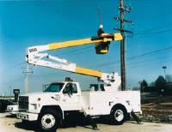
Bucket Truck (Cherry Pickers) Integrity Evaluation
Accidents, overloads and fatigue can all occur when operating bucket trucks or other aerial equipment. If a mechanical or structural defect is ignored, serious injury or fatality can result. In 1976, the Georgia Power Company pioneered the aerial manlift device inspection. Testing by independent labs and electrical utilities followed. Although originally intended to examine only the boom sections, the method is now used for inspecting the pedestal, pins, and various other components. Normally, the AE tests are second in a chain of inspections which start with visual checks. If necessary, follow-up tests take the form of magnetic particle, dye penetrant, or ultrasonic inspections. Experienced personnel can perform five to ten tests per day, saving valuable time and money along the way. ASTM F914 governs the procedures for examining insulated aerial personnel devices.
Others
- Fiber-reinforced polymer-matrix composites, in particular glass-fiber reinforced parts or structures (e.g. fan blades)
- Material research (e.g. investigation of material properties, breakdown mechanisms, and damage behavior)
- Inspection and quality assurance, (e.g. wood drying processes, scratch tests)
- Real-time leakage test and location within various components (small valves, steam lines, tank bottoms)
- Detection and location of high-voltage partial discharges in transformers
- Railroad tank car and rocket motor testing
There are a number of standards and guidelines that describe AE testing and application procedures as supplied by the American Society for Testing and Materials (ASTM). Examples are ASTM E 1932 for the AE examination of small parts and ASTM E1419-00 for the method of examining seamless, gas-filled, pressure vessels.

Sensor Sensitivity - Effects of Cables
The sensitivity of a sensor is governed by the intrinsic sensitivity of the piezoelectric material, the dimensions of the piezoelectric element, and the design and materials used in its case. Practically, one receives from a manufacturer a measured response curve to a standard signal and the capacitance of the sensor. This curve is often presented as if it were independent of the measurement technique. However, the sensitivity of a sensor will always depend, in part, on the equipment with which it is used. The open circuit voltage produced by a sensor is a property of the piezoelectric element and is
Vo(S) = Q(S)/Co (3.3)
where Q is the charge produced by a strain S, and Co is the capacitance of the sensor. When
connected to a preamplifier, the actual voltage across the input resistor of the preamplifier (given large input resistance) is
V(S) = Q(S)/(Co + Cc + CI) (3.4)
where Cc is the cable capacitance and CI is the input capacitance of the preamplifier. Acoustic emission sensors usually have a capacitance that falls between l00 and 1500 pf. Preamplifier input capacitances range between 20 and 40 pf. The capacitance per unit length of coaxial cables depends on the cables' impedance with approximate values of 30 picofarad (pf)/ft for 50 ohm cable, 20 pf/ft for 75 ohm cable and l5 pf/ft for 95 ohm cable. To see the range of this reduction in sensor sensitivity assume an input capacitance of 30 pf and 5 ft of 50 ohm cable. For a sensor with a capacitance of 100 pf, the output voltage would be V = 0.36Vo, or a decrease in sensitivity of 9 dB. A sensor of l600 pf capacitance would have V = 0.9 Vo , a decrease in sensitivity of l dB.

Thus, the loss in sensitivity can be appreciable for low capacitance sensors. Since most of the
extra capacitance comes from the cable, it is a good practice to keep the length of the cable
between the sensor and preamplifier as short as possible. This is also a problem for small
sensors, as the capacitance is directly proportional to the area of the disk.

3.1.7. Sensor Sensitivity - Effect of Preamplifier Noise
The spectral response curve of a sensor cable-preamplifier combination to an acoustic signal is shown in Fig. 3-3 Also shown are three response curves of the preamplifier without an acoustic signal. The exact shape of the spectral response of a sensor to an acoustic signal will
Figure 3-3. Frequency response of sensor-preamplifier combination. The top is the signal
response and the rest are no signal responses with the preamp input circuit open,
sensor only, or 50-ohm load only.

Sensor Calibration
All manufacturers furnish calibration curves with their sensors. The currently accepted units are dB referenced to l volt per meter per second. Many manufacturers will also furnish a calibration with dB units referenced to l volt per μbar. The acoustic signal used to calibrate the sensors may be either a surface wave or a compression wave. A typical calibration curve is shown in Fig. 3-1b. Calibration curves for the same transducer will not be the same for calibrations in velocity (meters/sec) or in pressure (μbar). Pressure is proportional to strain which is related to the surface displacement, while velocity is related to the time derivative of surface displacement. For a constant frequency the relationships are
Vdisplacement ≈ D sin ωt
(3.9)
Vvelocity ≈ d/dt (D sin ωt) =D ω cos ωt

Instrumentation
4.1.1. Acoustic Emission Systems
Analysis instrumentation was initially amplifiers, an oscilloscope, and an electronic counter. Computerized systems were then developed where signal parameters such as signal arrival time, rise time, peak amplitude, and duration were measured with analog circuits. These allowed the calculation of the locations of acoustic emission sources as well as more sophisticated displays and methods of analysis. However, they were limited by both the relatively slow processing speeds and small memories of the early computers, and the need for separate analog circuits for the detection of each desired acoustic emission parameter. Current computer systems are much faster and have far greater memory capacity. Instead of analog circuits for the acoustic emission signal parameters, they directly digitize the signals from the preamplifiers. This allows the use of any possible signal parameters in the analysis for which one can write a code. A commercial system may list twenty or more possible signal characteristics. In practice, however, the analysis of acoustic emission signals is often confined to digitized versions of the old analog parameters.Besides speed and versatility, the new computer technology has resulted in much smaller acoustic emission systems. Twenty-four channel systems, which started out requiring at least a full instrumentation rack, now consist of three 8-channel PCI cards and a notebook computer. Eight channels on a single card is currently a reasonable limit. This limit is determined partly by the number of co-axial connectors that one can fit on the input of a card and partly by the amount of circuitry still required for each channel. At present, coaxial cables are still required between the circuit boards and the sensor-preamplifier combinations in large multi-channel systems. Theuse of RF broadcast connections between the sensors and the computer are limited to systems
with only a few channels (part of this limitation is the need to use the same clock signal for every channel). Therefore, the rest of this paper assumes a notebook computer with a separate box containing multi-channel digital cards and coaxial cables to the sensors. Eight-channel cards are not quite as versatile as four- or two-channel cards – limitations include a slower maximum digitization rate and shorter maximum lengths for digitized signals. However, the increased versatility of the smaller cards’ digitizing capability is more important in laboratory experiments than in field tests.

Drawbacks involved in Digitization:
The limitation on the digitation rate is set by the frequency of the acoustic emission signals
emitted by the specimen. This content in turn is usually determined by the materials used in the specimen. The upper frequency of an acoustic emission event will be governed by the size of the region involved and the speed with which the movement occurs. On a microscopic scale, this can lead to quite high frequencies. However in tests involving structural materials, the detected frequencies will depend on the attenuation characteristics of the materials involved. For metals such as aluminum, steel, and titanium, frequencies up to one MHz are often detected. For lead and copper, maximum detected frequencies will be no more than 500 kHz; for plastics and composites, the maximum detected frequencies will be about 200 kHz. This maximum does not mean that higher frequencies will not be present, only that they will be minor components of the larger amplitude signals. This combined with the Nyquist criteria (the digital record must have at least two samples per wavelength of the highest frequency recorded to avoid inherent distortion) suggests that sampling rates of 2.0 MHz for plastics and composites and 10 MHz for metals are as high as is needed. The disadvantages of signals containing frequencies higher than half the Nyquist frequency is that these higher frequency components are aliased, or folded back, into the lower frequency range. In the worst cases, this can result in gross distortions of the original signal. If a lower sampling frequency is used, the low pass filters in the system should be set for considerably less than the Nyquist frequency

Measurement(Rise Time, hdt)
The basic measurement in a multi-channel acoustic emission system is the system time. This
starts when the test starts and stops when it ends. The PAC systems use a 4.0 MHz clock giving a time resolution of 0.25 microseconds. Every time a sensor detects a signal, the exact time of arrival in test time is recorded. Every channel of the system is independent, thus if a strong electromagnetic noise signal were to hit the system, every channel could record the same arrival time. Each channel also has its own clock which starts when the trigger threshold of that channel is first crossed. This channel clock runs until the signal drops below the threshold for a predetermined time or exceeds the programmed maximum signal length. This clock is used to determine the signal rise time and the signal length. Each channel has a set PDT (peak definition time). When the signal amplitude reaches a maximum and starts to decline, the card notes the time and maximum amplitude, and then waits an additional PDT to see if the previous signal amplitude is exceeded. If it is, the measurement continues. If there is no higher amplitude signal within the PDT, the previous amplitude is the peak amplitude and the time from the signal start is defined as the signal rise time.

Signal Energy:
The signal energy is easy to define but hard to measure with an analog circuit. It can be defined as the integral of the voltage squared vs. time curve over the signal length. The problem with an analog measurement is the dynamic range of the signals. If an AE test has a dynamic range of 80 dB, which is relatively common, then the energy range of those signals will cover at least eight orders of magnitude. Analog circuits with that dynamic range are not common. If AE signals all had the same signal characteristics then it might be possible to design analog circuitry to measure the energy. But AE signals come in a wide variety of shapes and sizes in the same test. For a digitized signal the signal energy is defined as
E = (Δt/R) Σi Vᵢ
2(t) = A(Δt/R) (4.1)
where Δt is the sample width in seconds, R is the resistance in ohms, Vᵢ(t) is the sample
amplitude in volts, and the summation is over T, the total signal length in seconds

Noise Suppression:
Noise can be defined as any signal detected by the AE system which is not a
desired response to the applied stimulus. This includes all types of electronic interference and
acoustic signals not produced by the stimulus as well as undesired responses to the applied
stimulus. In the past, electronic noise has been a major problem. Even transient signals, if they occur fast enough, can be superimposed and appear as a continuous signal. The response to such electrical noise has been improved shielding on sensors and preamplifiers, using double-shielded coaxial cable when needed and much improved filtering in system power supplies

++++
On the other hand, signals from defects in the part usually appear during the rising load at or near the peak. This is where flaw growth signals should be found. Current AE systems contain provisions for an electronically controlled voltage time gate.

The Fourier transform is important tool in engineering many other disciplines. Its discrete counterpart, the Discrete Fourier Transform (DFT), which is normally computed using the so-called Fast Fourier Transform (FFT), has revolutionized modern society, as it is ubiquitous in digital electronics and signal processing. Radio astronomers are particularly avid users of Fourier transforms because Fourier transforms are key components in data processing (e.g., periodicity searches) and instruments (e.g., antennas, receivers, spectrometers), and they are the corner stores of interferometry and aperture synthesis.

The Fourier transform is a reversible, linear transform with many important properties. For any function f(x) (which in astronomy is usually real-valued, but f(x) may be complex), the Fourier transform can be denoted F(s). The product of x and s is dimensionless
x is a measure of time t (i.e., the time-domain signal) s corresponds to inverse time, or frequency (i.e., the frequency-domain signal).

The Fourier transform is defined by
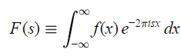
which is usually known as the forward transform, and
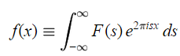
which is the inverse transform.
In both cases, i−1 . Alternative definitions of the Fourier transform are based on angular frequency (=2), have different normalizations, or the opposite sign convention in the complex exponential. Since Fourier transformation is reversible, the symmetric symbol is often used to mean "is the Fourier transform of"; e.g., F(s)f(x) .
The complex exponential is the heart of the transform. A complex exponential is simply a complex number where both the real and imaginary parts are sinusoids. The exact relation is called Euler's formula
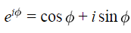
Complex exponentials are much easier to manipulate than trigonometric functions, and they provide a compact notation for dealing with sinusoids of arbitrary phase, which form the basis of the Fourier transform. Complex exponentials (or sines and cosines) are periodic functions, and the set of complex exponentials is complete and orthogonal. Thus the Fourier transform can represent any piecewise continuous function and minimizes the least-square error between the function and its representation.

Thus an analog electronic filter will convert a sine wave into another sine wave having the same frequency (but not necessarily the same amplitude and phase), while a filtered square wave will not be a square wave. This property of complex exponentials makes the Fourier transform uniquely useful in fields ranging from radio propagation to quantum mechanics.

The Discrete Fourier Transform

The continuous Fourier transform converts a time-domain signal of infinite duration into a continuous spectrum composed of an infinite number of sinusoids.

Discrete Time Fourier Transform:
In astronomical observations we deal with signals that are discretely sampled, usually at constant intervals, and of finite duration or periodic. For such data, only a finite number of sinusoids is needed and the Discrete Fourier Transform (DFT) is appropriate. For almost every Fourier transform theorem or property, there is a related theorem or property for the DFT. The DFT of N uniformly sampled data points x_{j} (where j=0N−1) and its inverse are defined by
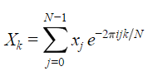
and
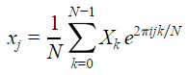
Once again, sign and normalization conventions may vary, but our definition is the most common. The continuous variable s has been replaced by the discrete variable (usually an integer) k.The result of the DFT of an N-point input time series is an N-point frequency spectrum, with Fourier frequencies k ranging from −(N2−1) , through the 0-frequency or so-called "DC" component, and up to the highest Fourier frequency N/2. Each bin number represents the integer number of sinusoidal periods present in the time series. The amplitudes and phases represent the amplitudes Ak and phases k of those sinusoids. In summary, each bin can be described by Xk=Akeik .
For real-valued input data, however, the resulting DFT is hermitian—the real-part of the spectrum is an even function and the imaginary part is odd, such that X−k=Xk, where the bar represents complex conjugation. This means that all of the "negative" Fourier frequencies provide no new information. Both the k=0 and k=N/2 bins are real-valued, and there is a total of N/2+1 Fourier bins, so the total number of independent pieces of information (i.e. real and complex parts) is N, just as for the input time series. No information is created or destroyed by the DFT.
Other symmetries exist between time- and frequency-domain signals as well:
Time Domain | Frequency Domain
real | hermitian (real=even, imag=odd)
imaginary | anti-hermitian (real=odd, imag=even)
even | even
odd | odd
real and even | real and even (i.e. cosine transform)
real and odd | imaginary and odd (i.e. sine transform)
imaginary and even | imaginary and even
imaginary and odd | real and odd
Usually the DFT is computed by a very clever (and truly revolutionary) algorithm known as the Fast Fourier Transform or FFT. The FFT was discovered by Gauss in 1805 and re-discovered many times since, but most people attribute its modern incarnation to James W. Cooley and John W. Tukey ("An algorithm for the machine calculation of complex Fourier series," Math. Comput. 19, 297–301) in 1965. The key advantage of the FFT over the DFT is that the operational complexity decreases from O(N2) for a DFT to O(Nlog2(N)) for the FFT. Modern implementations of the FFT (such as FFTW) allow O(Nlog2(N)) complexity for any value of N , not just those that are powers of two or the products of only small primes.

Example: Estimate the speed increases obtained by computing the FFTs instead of DFTs for transforms of length 103, 106 , and 109 points.
speed improvement(N=103)N2Nlog2(N)=Nlog2(N)10103100
speed improvement(N=106)Nlog2(N)201065104
speed improvement(N=109)Nlog2(N)301093107

Sampling Theorem

For a DFT to represent a function accurately, the original function must be sampled at a sufficiently high rate. The appropriate rate for a uniformly sampled time series is determined by the Nyquist-Shannon Theorem or Sampling Theorem. This theorem states that any continuous baseband signal (signal extending down to zero frequency) may be identically reconstructed if the signal is bandwidth limited and the sampling frequency is at least twice the bandwidth of the signal (i.e. the highest frequency of a baseband signal). That critical sampling rate, 1t, where t is the time between successive samples, is known as the Nyquist rate, and it is a property of the time-domain signal based on its frequency content. Somewhat confusingly, if a time-domain signal is sampled uniformly, then the frequency corresponding to one-half that rate is called the Nyquist frequency,

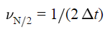
The Nyquist frequency describes the high frequency cut-off of the system doing the sampling, and is therefore a property of that system. Any frequencies present in the original signal which are at higher frequencies than the Nyquist frequency will be aliased to other lower frequencies in the sampled band as described below. If that signal was band-limited and then sampled at the Nyquist rate, in accordance to the Sampling Theorem, no aliasing will occur.

Cross Correlation

In signal processing, cross-correlation is a measure of similarity of two waveforms as a function of a time-lag applied to one of them
For continuous functions f and g, the cross-correlation is defined as:
.
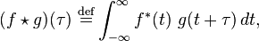
where f* denotes the complex conjugate of f and is the time lag.
Similarly, for discrete functions, the cross-correlation is defined as:

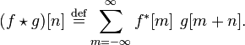

Power Spectral Density:
Power spectral density function (PSD) shows the strength of the variations(energy) as a function of frequency. In other words, it shows at which frequencies variations are strong and at which frequencies variations are weak. The unit of PSD is energy per frequency(width) and you can obtain energy within a specific frequency range by integrating PSD within that frequency range. Computation of PSD is done directly by the method called FFT or computing autocorrelation function and then transforming it.
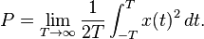

Dominant Frequency:

There are many situations when the observed data show a periodic behaviour due to one frequency, called the dominant frequency, which carries the maximum energy among all frequencies found in the spectrum.

